**FNC EMadbatah Application**

**Deployment Guide.**

1. Pre-requisites:
2. SQL Server 2005 or higher installed
3. IIS 7 Installed and running (full install)
4. ASP.Net 4.0 installed IIS <http://www.microsoft.com/download/en/details.aspx?id=17718>
5. Data connectivity components (64bit)

<http://www.microsoft.com/download/en/details.aspx?id=13255>

1. Microsoft Office Word 2007 Enterprise.
2. After office Install hotfix <http://go.microsoft.com/?linkid=9706290>
3. 2007 Microsoft Office Add-in: Microsoft Save as PDF or XPS <http://www.microsoft.com/download/en/details.aspx?id=7>
4. Install BullZip PDF Printer <http://www.bullzip.com/products/pdf/download.php>
5. Run the .bat and the .reg file for registry configuration for bullzip
6. Install Open XML SDK <http://www.microsoft.com/download/en/details.aspx?id=5124>
7. Project Package:
   1. Zip file : **EmadbatahWeb.zip** (e-Madbatah website contents)
   2. Zip file : **EPServiceWeb.zip** (e-Parliament Service website contents)
   3. Zip file : **CreateEadbatahDBScript.zip** (script for creating the App database)
   4. Zip file : **EMadbatahAppSrc.zip** (source code of the application VS2010 solution)
   5. Word file **EMadbatah- Deployment-Guide.docx** (deployment instructions)
   6. Bullzip configuration folder (contain .bat and .reg files)
8. Database.
9. Login to the database server instance that will hold the App database
10. Open the script file create-madbatah-db.sql and change the FILENAME Values (in **Bold**) to be suitable with your environment. Or just create this path “**C:\Databases\EMadbatah\”**.

NAME = N'EMadbatah2', FILENAME = **N'C:\Databases\EMadbatah\**EMadbatah2.mdf' , ….

NAME = N'EMadbatah2_log', FILENAME = N'**C:\Databases\EMadbatah\**EMadbatah2_log.ldf' ….

1. Run the script create-madbatah-db.sql. (this acript
2. Wait for the script to finish execution.
3. The database is ready. You can do fast check to see if it is exist and the login emadbatahuser exist.
4. IIS.
   1. Make sure IIS is installed and running.
   2. ASP.NET Registration:
      1. Open your command prompt (Windows + R) and type cmd and press ENTER  
         You may need to start this as an administrator if you have UAC enabled.  
         To do so, locate the exe (usually you can start typing with Start Menu open), right click and select "Run as Administrator"
      2. Type cd C:\Windows\Microsoft.NET\Framework\v4.0.30319\ and press ENTER.
      3. Type aspnet_regiis.exe -ir and press ENTER again.
      4. At this point you will see it begin working on installing .NET's framework in to IIS for you
      5. Note that in case of a 64-bits server then you should run the above command from Framework64
      6. Close the DOS prompt
   3. Enable ASP.NET 4.0 in IIS
      1. Open IIS Manager
      2. Under Web Service Extensions, Allow ASP.NET 4

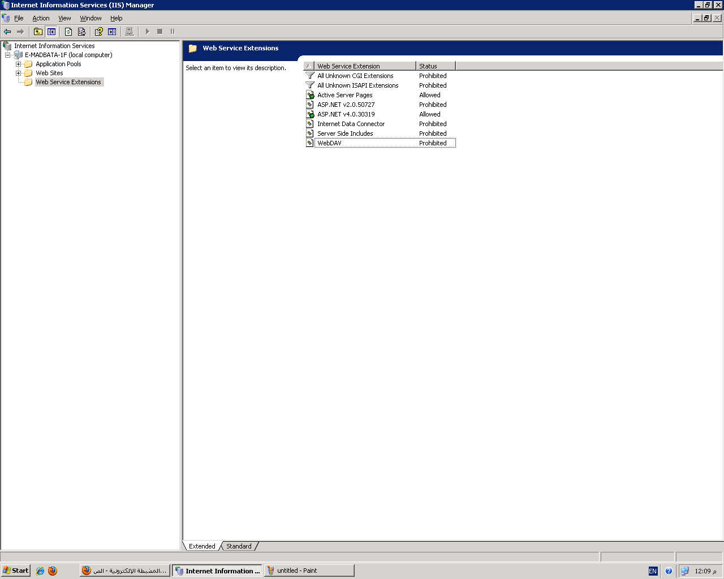

* 1. Create 2 folders in the path C:\Websites (or another suitable path)

C:\Websites\EMadbatahWeb to hold app main website

C:\Websites\EPServiceWeb to hold E-Parliament web service

C:\Websites\HealthTool to hold Health tool website

Note: Then copy each website content from its corresponding zip file.

* 1. Give full control permission to the 2 folders for the users:
     1. NetworkService
     2. Eparmossadmin
     3. IIS user

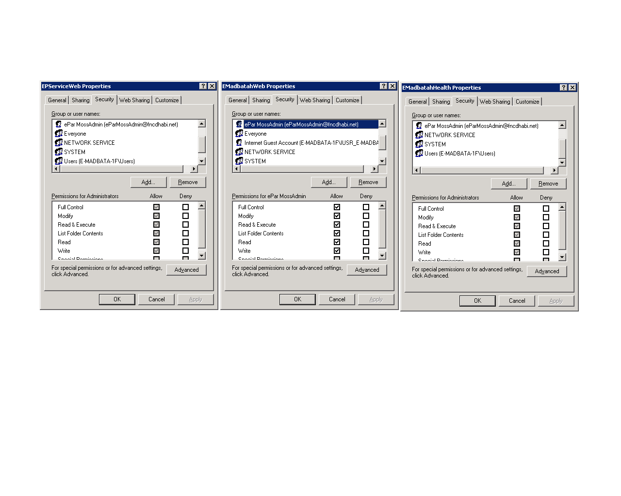

* 1. Create Website for the E-Madbatah App as shown in the following screens:
     1. Open IIS Manager
     2. Right Click on sites and choose “Add Web Site…”
     3. Create a new website for each of the 3 components (madbatahWeb, Service and Health tool) using the new website wizard:
        1. Give a different port for each website (10000,10001,10002)
        2. Allow anonymous access
        3. Give read, run and execute permissions
     4. For each of the websites, create an application pool with the default settings
     5. Adjust the properties of websites and pools as below:

Website Properties:

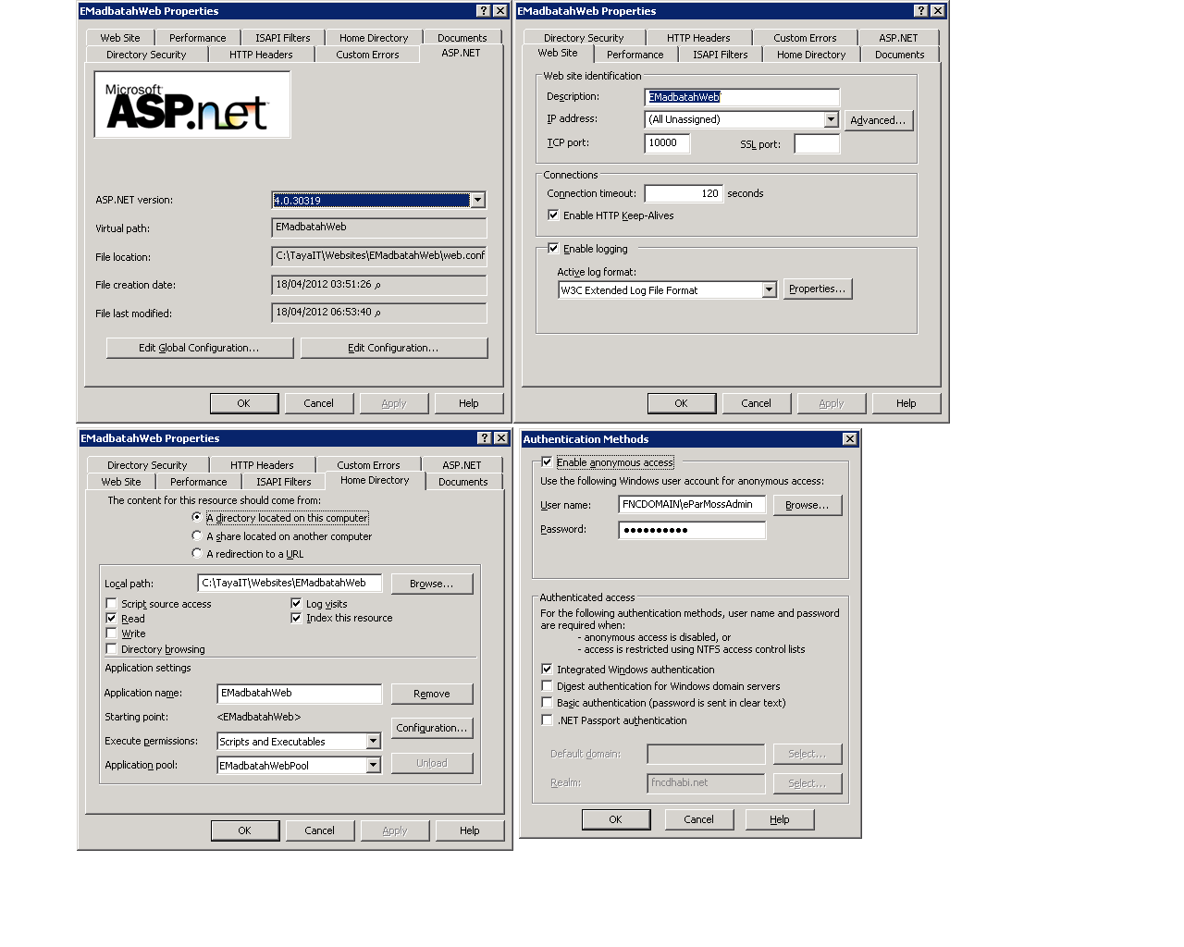

Website Pool Properties:

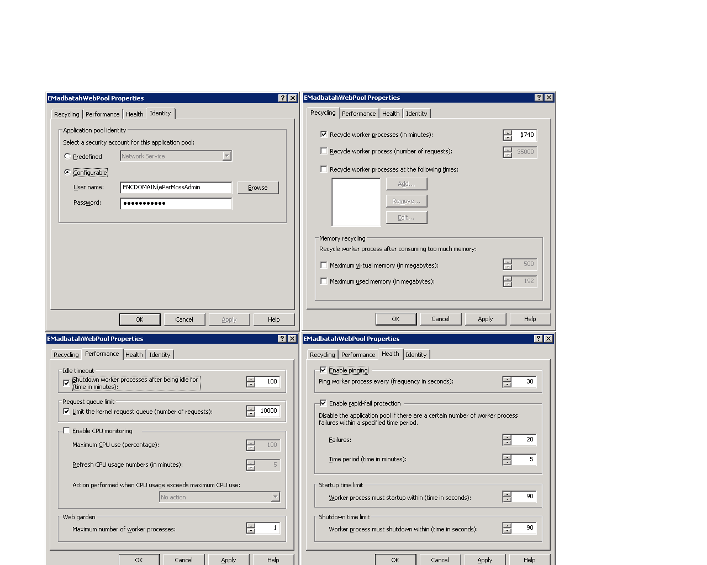

Service Properties:

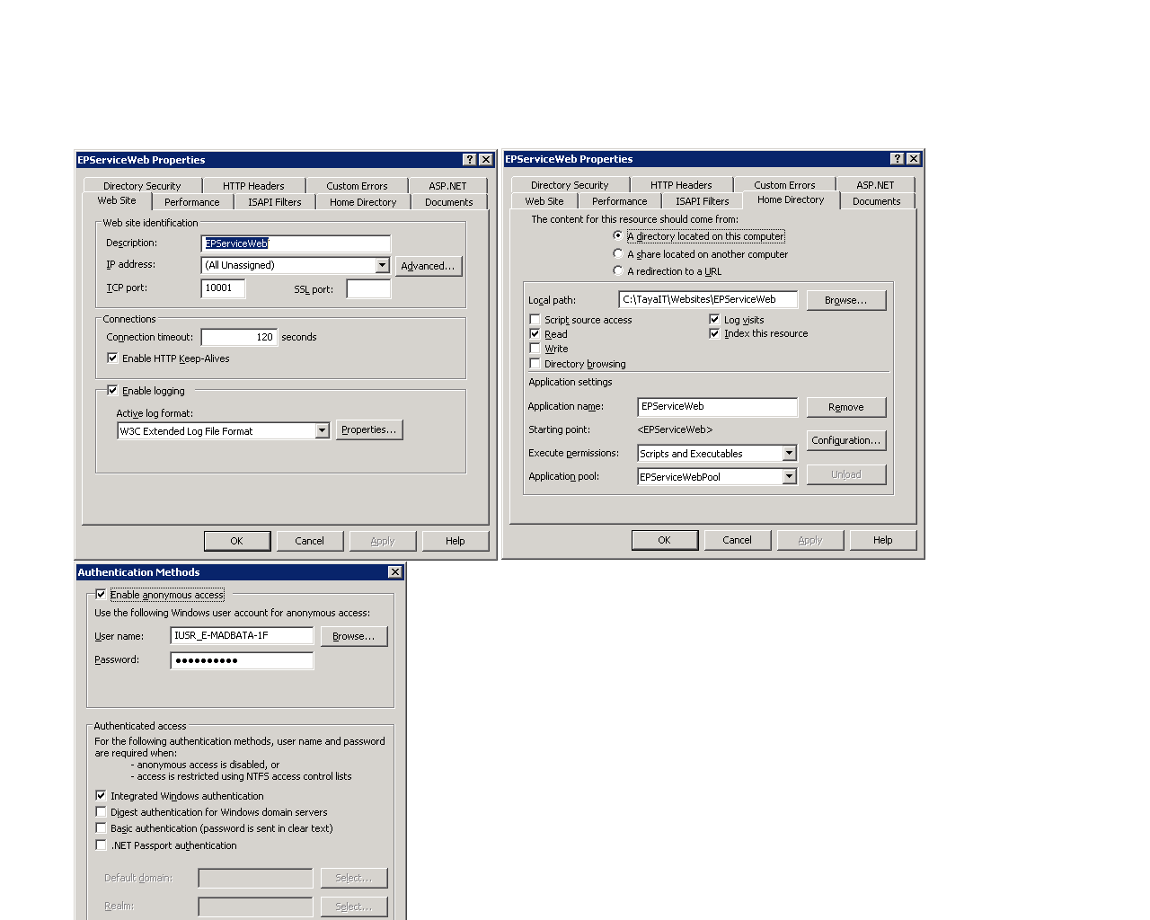

Service Pool Properties:

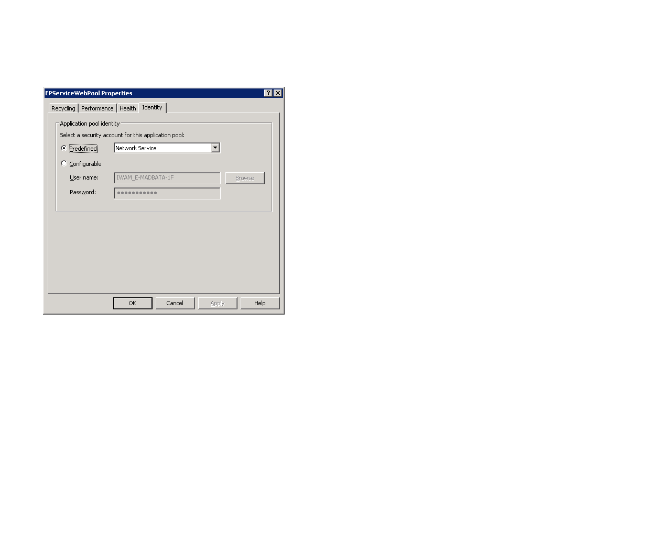

HealthWebsite Properties:

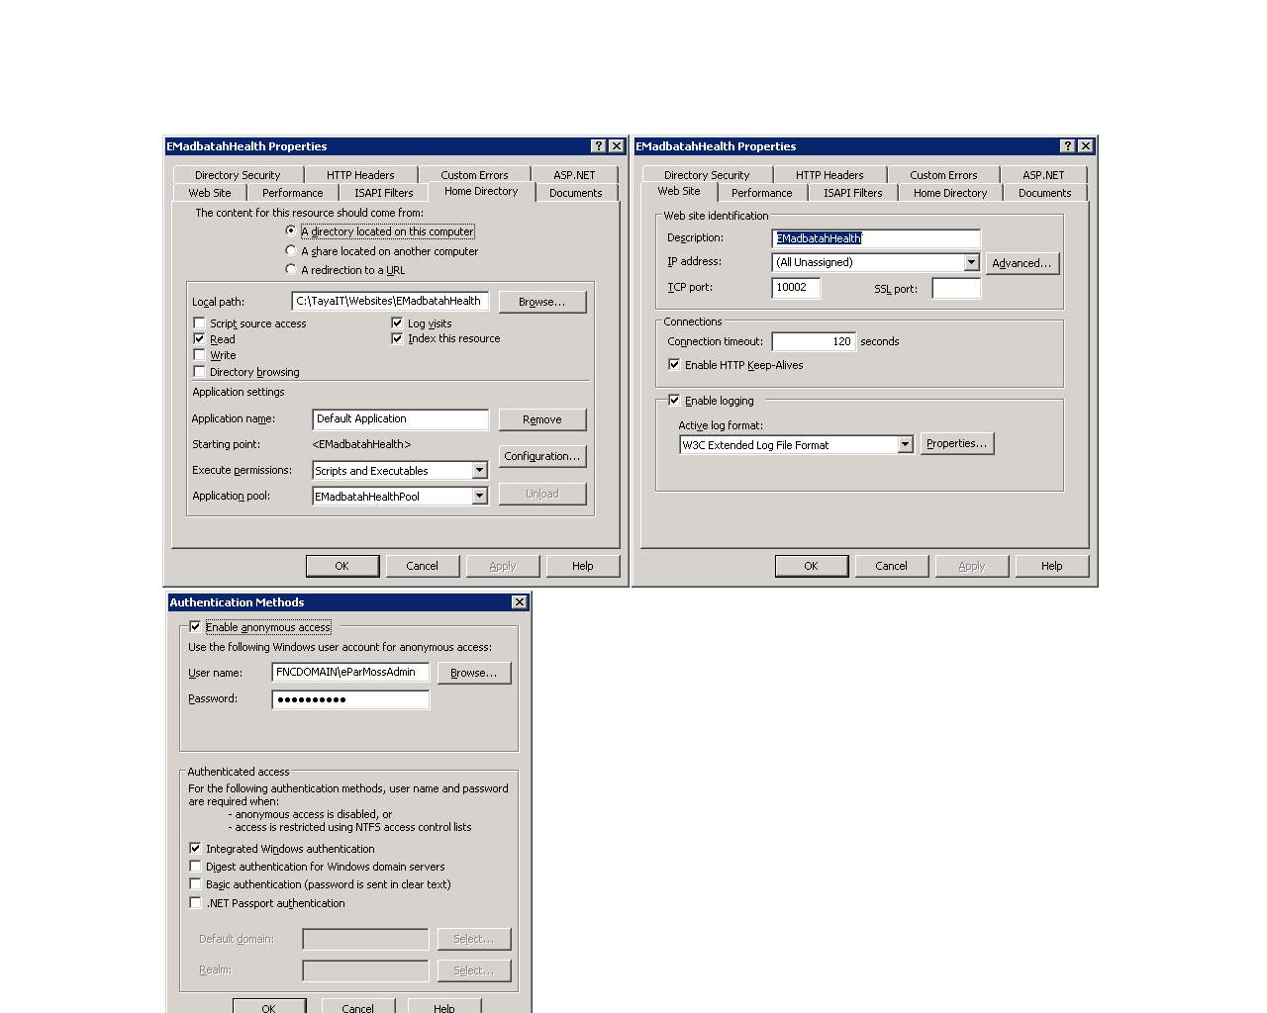

HealthPool properties:

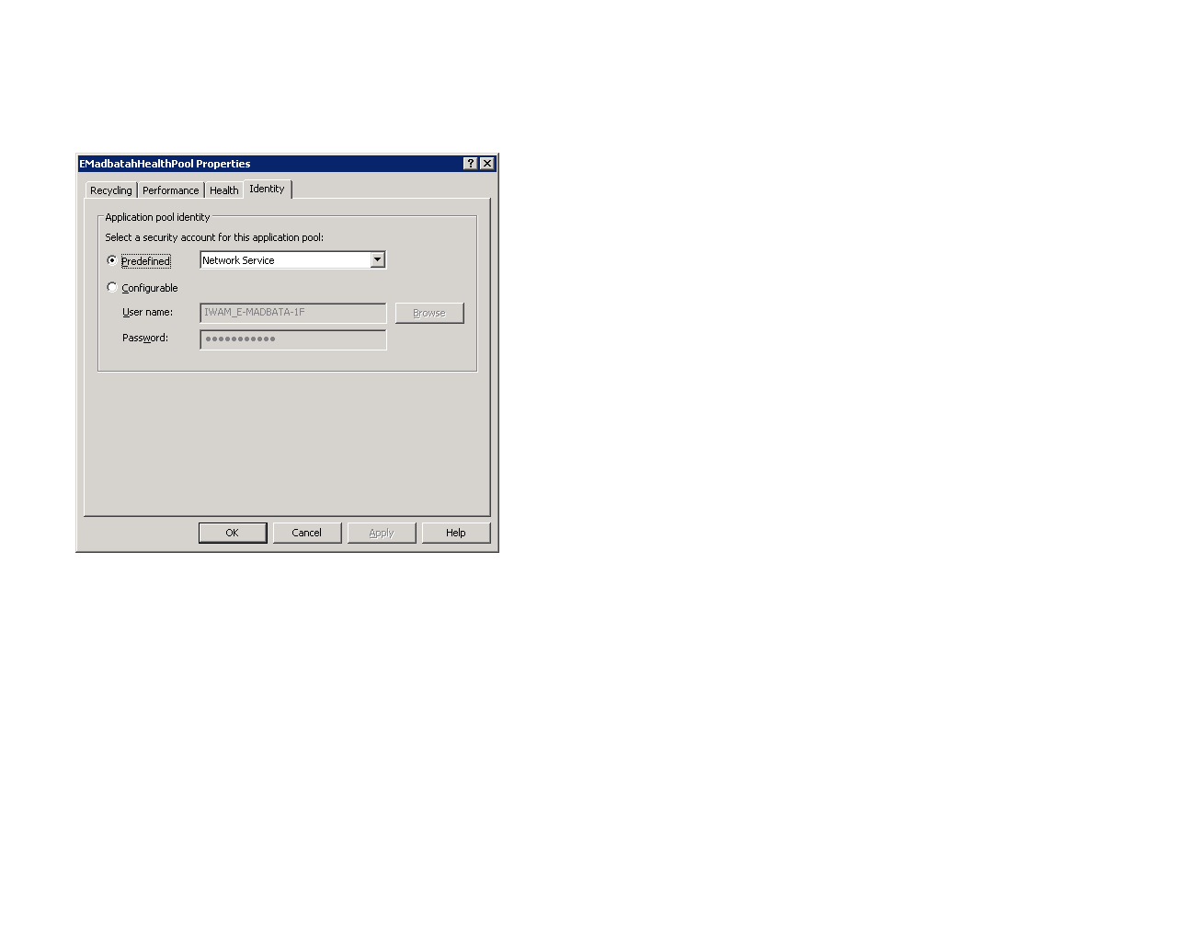

1. To be able to make a user identity on the pool, you should add this user to the groups IIS_WPG and Users as below:

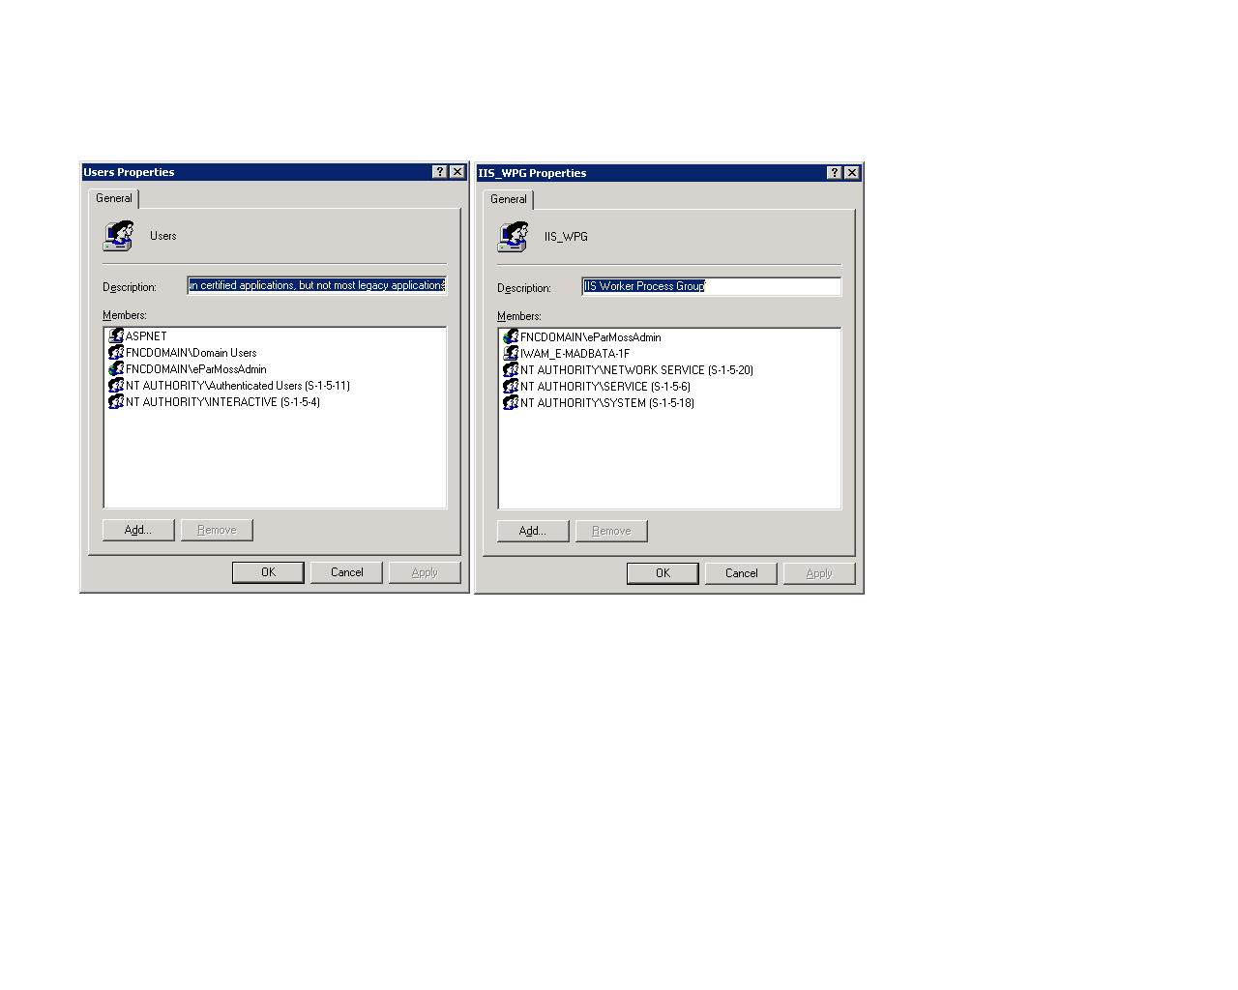

1. Website Configuration:
   1. **Web.Config**

Under the <connectionStrings> section change the IP part for the database connection string

**EMadbatahEntities**: change the Data Source to match the IP of the machine holding the database.

And change:

For ADConnectionString change the connectionString to match your Active Directory Configuration.

In MyADMembershipProvider under membership section

For connectionUsername put valid AD user

For connectionPassword put password for that user

ExecutionTimeOut should be adjusted as

<http://weblogs.asp.net/tanzimsaqib/default.aspx?PageIndex=2>

* 1. Under the **App_Data** folder file **AppSettings.xml**

Set the following values:

* + 1. VecSysServerPath : the path of the root folder containing all sessions folders.
    2. AudioServerPath : the path of the root folder containing all Audio folders of all sessions.
    3. EParlimrntWebServiceURL : If Service is deployed on another machine set new URL.
    4. AllowedDomainName : name of the Active directory domain (if user name is Develop\unada, then here we put Develop).
    5. In the DefaultAdmin section put the Main Admin Info
    6. Under the EmailServer section Email Server Details for the notification emails work properly

1. First Run:
   1. Start the website by opening it in the browser.
   2. You are currently Admin. You can open System Admin page -> then to Users Management. Add Users and assign their roles, and info.
2. Directory watcher:
   1. Build the project “TayaIT.DirectoryWatcher” in release configuration
   2. Build the project “TayaIT.DirectoryWatcher.WindowsService” in release configuration
   3. Put the contents of the above builds in the same folder
   4. Upload it to the server.
   5. Create a directory for the DirectoryWatcher solution
   6. Add full control privilages to the user eparmosadmin on this folder
   7. Adjust the settings in settings.xml file, user should be set to [eparmosadmin@fncdhabi.net](mailto:eparmosadmin@fncdhabi.net)
   8. Double click the exe called “TayaIT.DirectoryWatcher”
   9. Press deploy and start service
   10. After getting the message “deployed and started successfully”
   11. Go to services manager “from run command, type service.msc then enter”
   12. Stop the service called “TayaITDirectoryWatcherService” and start it again